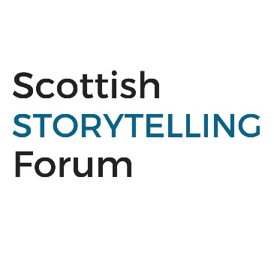
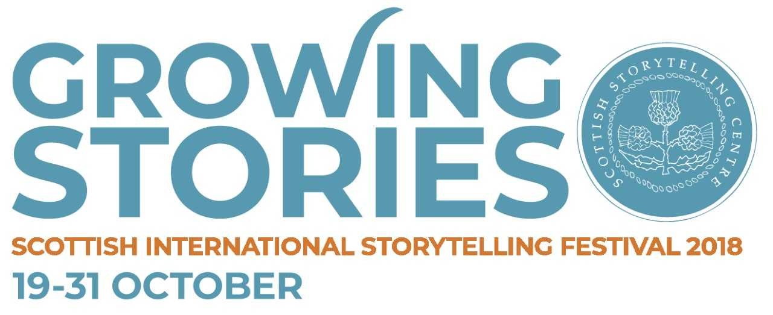

How to promote your event

The Local Storytelling Campaign takes places 17 Sep- 30 Nov and communities and schools are encouraged to hold storytelling events under the theme of Growing Stories. We would love to hear how you are celebrating so please get in touch with your Storytelling Network Co-ordinator, Miriam Morris: miriam@tracscotland.org and let her know about your event.

You can hold your event at any time however, Wednesday 07 November will be an online showcase day, so you may wish to hold your event then and share your content online on this date.

We hope that you can join in on the big story by sharing all your activity with us online with the hashtag #GrowingStories and tagging us in all your social media posts. This resource offers you tips on the following:

- Social media tips
- Press & media tips
- Free templates: Press Release and media photocall

Please note: we have logos and promotional materials such as an empty belly promo poster that you may want to use to publicise your event.

Social Media: #GrowingStories

Social Media is a great tool to help you promote your event and connect with others to share and spread information.

Why use social media?

- You can reach new audiences and inspire new people in your network or community to get involved.
- You can use social media to build excitement in the weeks leading up to your event.
- It can be a networking tool and a means to make connections with others in your field of work or in your network

To keep up-to-date with all the #GrowingStories info, follow us on social media and help share content:

Facebook:

Please like and join the Storytelling Forum page on facbook.
https://www.facebook.com/search/top/?q=scottish%20storytelling%20forum%20(tracs)

Please share any updates we post on Facebook

If you or your organisation has a Facebook page, please let us know so that we can connect and help share your information also: miriam@tracscotland.org

Twitter:

Please follow Scottish Storytelling Forum on Twitter:

https://twitter.com/?logged_out=1&lang=en / @scotstoryforum

Please tag any of your tweets @scotstoryforum so that we can retweet your info

Instagram:
We’ll be sharing some striking images from the Scottish Storytelling Centre account on Instagram. Please follow us there.

Some things you may want to consider:

- Create a Facebook events page for your event (https://en-gb.facebook.com/help/210413455658361 )
- Share any activity on Facebook, Twitter or Instagram with the hashtag: #GrowingStories please do not create your own hashtag as this means we will not be able to find and share your activity!
Press and Media
The art of brand building and PR involves using messages that inspire conversation and sharing among target audiences.

PR is all about looking for the story that will bring a brand’s messages to life. Journalists are busy professionals, giving them a half-baked story isn’t an option. Similarly, if the story is playing out on social media, then audience attention is finite. Only quality, well thought-out stories will gain traction

Luke Mackay, associate director at PR firm Edelman

What is PR and brand building?
Word-up folks. PR and brand promotion is…. Storytelling!

Apt, huh?
PR is a great way to reach many audiences and promote your event without spending a lot of money on promotion. A good way to get media interested is to provide them with newsworthy stories or eye-catching photographs.
A easy way to do this is to send a press release to local press.
Writing your press release
- At the top if email write PRESS RELEASE followed by FOR IMMEDIATE RELEASE if this is the case or EMBARGOED UNTILL plus relevant date and time
- Have a catchy headline. Try to imagine that you are reading it as a headline that has already ran in print. For example:
A Never-ending Story: Stirling School Takes Part in Storytelling Relay
- Make your first paragraph a short summary of what you are announcing
Here are some tips to consider
- Stick to one subject.
- Remember that press releases are news. Only present the facts. Not false news
- Create an angle or ‘hook’ for your subject.
- Try to stick to one page, two at the most.
- Paste press release into body of the email, do not attach as a word doc.
- Include one or two quotes
- Only send photos to picture desks, unless requested
- Then follow with: Who, What, Where, When and Why
- Give details of any well-known people or involved – have you got a local MP, artist, storyteller, author or mascot taking part? Mention this.
- Try to include at least one quote. Good spokespeople include the head of the school, the organiser or a special person taking part.
- Insert Note to Editors at the end of the release.
- Don’t forget to include your contact details and a mobile number at the end of your release.
- Ensure that your press release clearly states whether photographers are welcome to attend.
- Remember to add any other links to where they can find out more info such as your website if you have one.
Sending it to press
Okay, so you’ve got your press release, next up… distribution in five steps.
- Build a media list. This is a spreadsheet containing the contact information for media agencies in your niche. When building your media list, you typically want to identify outlets that are most relevant to your press release topic and desired audience.
- Find out the publication day and print deadlines of your local paper and send them the release in plenty of time.
- Direct contact or general news desk? Submitting the release usually involves emailing the press release to your contact at the news agency if you have identified a contact but most have a general news desk email which is easy to find online or it is mentioned in your local paper.
Timing is key, here’s some tips for when you need to get in touch:

- Monthly magazine - 2 months
- Weekly paper - 3 weeks
- Daily paper - 1-2 weeks
- TV weekly show - 3 weeks
- TV daily show - 1-2 weeks
- Radio - same as TV
- If your press release is timely, such as the case with an event, make sure you submit at least one to two weeks in advance!
- Remember to paste your copy in to the email rather than attaching as a word doc and have a catchy headline in the subject box.
If you would like help with press contacts, get in touch with Miriam@tracscotland.org
Pitch Perfect
Uncovered a story about a suspected 1700s local witch when organising your storytelling event? Are you an expert on certain topic that’s mentioned in your event?

That’s a hook and worth a pitch!

As well as sending a release, you could pitch an interview or feature separately. If you think there is an angle to your event that has a worthy hook for an interview or feature, don’t be afraid to get in touch with a journalist and promote it that way asking if it would be of interest.
Pitching in 5 steps:

- Personalise your pitch with an appropriate greeting. Have you read their work before? Mention this.
- If you don’t know the journalist/editor, briefly introduce yourself in the email
- Tailor your pitch to that publication – what’s the writing style and tone? It helps if your pitch mirrors this, so editors can see that your story would fit well in their publication.
- Establish an angle. Think about what you can offer them, to distinguish it from advertising and suggest that you are happy to help with images and copy, journalists are busy people!
- Pitch by phone or email and remember to plug your event.
Media Photocall and Images

Photos and a good succinct image caption are often a sure way of getting coverage and helping to promote your event.

Here’s some things to think about when arranging your photocall:

- Think of the image and the angle. Like your press release, think of what it is your trying to capture/say and make your idea sharp and clear.
- Think of what you can include. Somethings that work well in media calls are:

Fancy dress
Mascot
Children
Animals
Props, banners, balloons. Think striking and colourful!

- Keep it simple and non-cluttered
- Have a succinct caption ready to offer press that includes vital information about your event, including times, location and title.

If you have budget you may want to hire your own photographer to attend as well extending the invitation to press. This means if no one turns up, you can still capture the shot and wire to press yourself. If doing this option, remember:

- Only send photos to newspaper picture desks
- Don’t send anything bigger than 4MB
- Include your caption with images
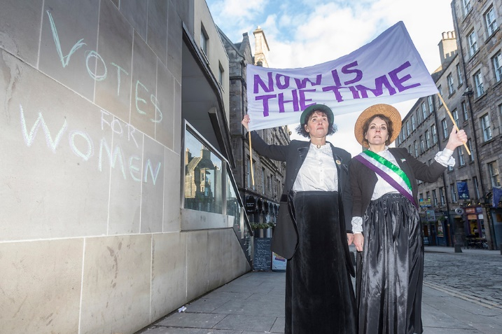

Here’s an example of photocall to promote a recent storytelling event that focused on Scotland’s suffragette movement. Staging this ensured coverage in most nationals in Scotland and it was relatively easy to organise as it’s striking without very many props!

Things to consider

You may also want to invite photographers to attend your event so that they can share an image after it has taken place. It’s a nice way of capturing the success of the event and building connections/contacts for future events you may hold.

Photo Permissions: Make sure you have permission from those attending the event or taking part in the photocall. Especially if there are children in the photograph.
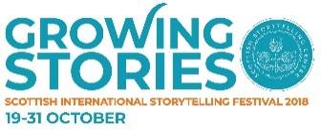
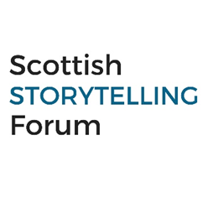

FOR IMMEDIATE RELEASE (or embargo if required)

HEADLINE: Stirling Primary to take part in Storytelling Relay with Local Storyteller

Stirling Primary is holding a Storytelling Relay to celebrate Scotland’s Local Storytelling Campaign, “Growing Stories” on Wednesday 7 November.

The Growing Stories Campaign (17 Sep - 30 Nov) focuses on the local angle and reach of the Scottish International Storytelling Festival that takes place each year at the end of October.

During the months of Sep-November schools and communities are encouraged to take part in an initiative that celebrates the art of storytelling. The “Growing Stories” campaign aims to help communities connect, grow together and celebrate the important role that stories play in preserving heritage and cultures for new generations.

Audiences across Scotland are invited to book a storyteller for a local event, strike-up new community activity and engagement and share all the wonderful storytelling activity in their community.

To celebrate Stirling Primary are holding a WRITE ABOUT THE WHO, WHAT, WHERE, AND WHEN OF YOUR EVENT HERE.

INCLUDE FIRST QUOTE: “We’re delighted to be holding an event to celebrate this year’s Local Storytelling Campaign with storyteller Jess Smith. The school is excited to hear and share stories with the rest of the school. Storytelling offers such a dynamic and creative approach to learning and this campaign offers the perfect platform to experience this in a new and engaging way!” Shelia Jones, Principal of Stirling Primary

Storyteller Jess Smith will begin by reciting tales to primary ones who will then pick the next “baton-tale” that Jess must pass on to the next class and so forth. The day will accumulate in a large storytelling assembly in which parents and guardians are welcome to attend and listen to the last tale that closes the school day before returning home to share the final tale before bed.

INCLUDE SECOND QUOTE: “I am really looking forward to sharing local tales with each class of Stirling Primary and hopefully some parents too! Stories are a magical way of bring us together and help us discover and explore the hidden gems or folklore connected to the area we live in.” Jess Smith, local Storyteller.

Contact and more info You can find out more about the Stirling Primary’s Storytelling Relay by contacting Shelia Jones Contact Info
You can find out more about the local storytelling campaign by visiting: https://www.sisf.org.uk/ or if you would like to know more about arranging an event or booking a storyteller, contact Storytelling Network Co-ordinator, Miriam@tracscotland.org

Ends
Notes to editors

i.SISF is organised by Traditional Arts and Culture Scotland (TRACS).
ii.TRACS is a Scottish Charitable Incorporated Organisation that brings together three forums: The Scottish Storytelling Forum, The Traditional Dance Forum of Scotland and The Traditional Music Forum in a collaborative alliance designed to improve the knowledge, practice, development and advocacy of Scotland’s traditional arts in a contemporary world. TRACS is TRACS is supported by Creative Scotland and the City of Edinburgh Council.
iii.The Scottish Storytelling Forum (SSF) is a diverse network of storytellers, organisations and individuals supporting Scotland’s vibrant storytelling community. The SSF is ran under TRACS umbrella.

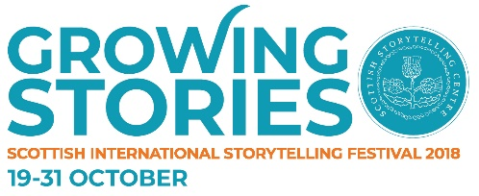

Media Call: Stirling’s Storytelling Relay

Camera crew and photographers are invited to attend a photocall at Stirling Primary on Wednesday 24 October to mark the launch of Storytelling Relay that will take place as part of Scotland’s Local Storytelling Campaign, “Growing Stories”.

Who: Stirling Primary invite media crews to attend media call to launch a Storytelling Relay
When: Wednesday 24 October
Time: 1.30-2pm
Where: (exact location of where photograph will take place)

Background:

Stirling Primary is holding a Storytelling Relay to celebrate Scotland’s Local Storytelling Campaign, “Growing Stories”.

The Growing Stories Campaign (17 Sep - 30 Nov) focuses on the local angle and reach of the Scottish International Storytelling Festival that takes place each year at the end of October. Schools and communities are encouraged to take part in an initiative that celebrates storytelling under a theme. This year’s theme, Growing Stories highlights how stories help communities connect, grow together and celebrate the important role that stories play in preserving heritage and cultures for new generations.

To celebrate Stirling Primary are holding a Storytelling Relay (Briefly expand on event).

Photograph Opportunity:

Photograph with local storyteller, Jess Smith, poised to run with over-sized colourful baton passing to a line of children who will be dressed as famous characters from fairy and folk tales, such as Little Red Ridinghood.

Interview Opportunity:
Children, storyteller and principal of school

Please confirm attendance and if you need any further information, contact
Shelia Jones, Principal of Stirling Primary Shelia.jones@madeupemailaddress.com

Notes to editors

i.SISF is organised by Traditional Arts and Culture Scotland (TRACS).
ii.TRACS is a Scottish Charitable Incorporated Organisation that brings together three forums: The Scottish Storytelling Forum, The Traditional Dance Forum of Scotland and The Traditional Music Forum in a collaborative alliance designed to improve the knowledge, practice, development and advocacy of Scotland’s traditional arts in a contemporary world. TRACS is TRACS is supported by Creative Scotland and the City of Edinburgh Council.
iii.The Scottish Storytelling Forum (SSF) is a diverse network of storytellers, organisations and individuals supporting Scotland’s vibrant storytelling community. The SSF is ran under TRACS umbrella.

